Tools/equipment required:

- Hand Pump Calibrator for Field Calibration
https://www.amazon.com/Pressure-Calibrator-Field-Calibration-Instruments/dp/B08GSKPJZ3

- Fluke 726 Precision Multifunction Calibrator
https://www.fluke.com/en/product/calibration-tools/multifunction-calibrators/fluke-726

- Standard electrical multi meter
- Pneumatic impact wrench for quick flange assembly
- Full set of mechanical hand tools (spanners, screw drivers, sockets, wrenches)
- 3-inch, 4 inch, 12 inch standard open flanges + blind flanges (for burst disc procedures to clean piping)
- 4 sqm (square meters) of standard gasket paper
- Flexible plastic ¼” quick connect hose (20m) and fittings

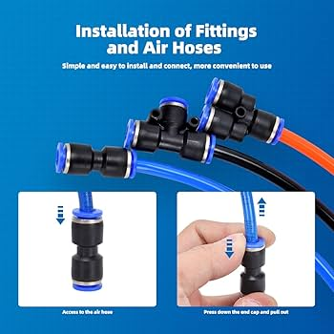

- Laser temperature gun (infrared)

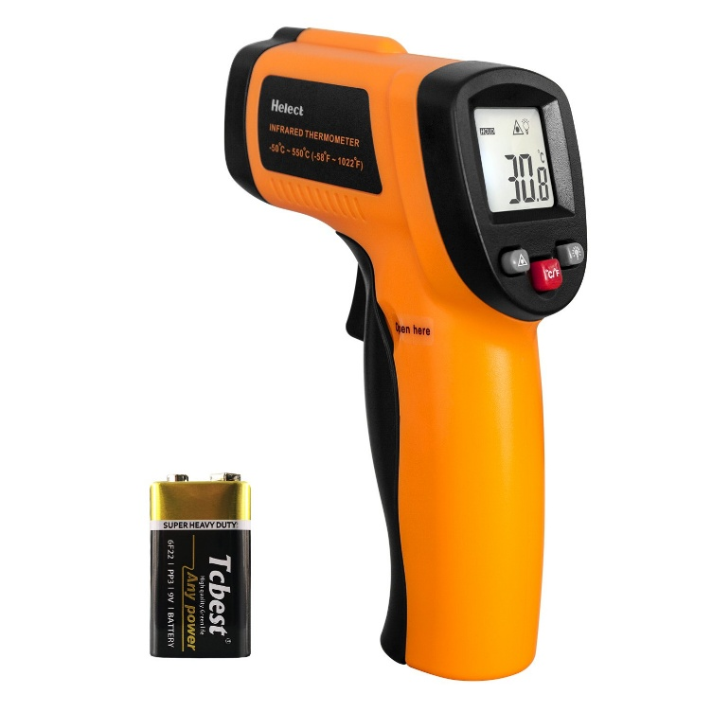

- Handheld dewpoint/RH meter able to read -60C dewpoint

